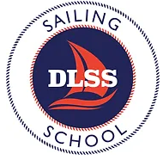

Please fill out this form to make a donation to the Delavan Lake Sailing School.
The form can be emailed to “DelavanLakeSailingSchool1955@gmail.com” or mailed to: Delavan Lake Sailing School, P.O. Box 72, Delavan, WI. 53115.
You can choose to have your entire donation directed toward 1 fund or select multiple funds to have the donation equally split, unless you specify otherwise:
- Opti equipment
- X-Boat equipment
- Coach boats
- Coach salaries
- Coach education fund
- Regatta expenses
- Awards Ceremony
- Mary Beers Adult Sailing Fund
- General Fund

Please indicate the Amount of the donation: $ ________________
Please indicate payment method:
- Check (mail to the above address)
- Credit Card/Debit Card (on the DLSS website, select the Donate tab, then click on the Donate button)
- Paypal (on the DLSS website, select the Donate tab, then click on the “Donate” button)
Name ______________________________________________
Phone ______________________________________________
Email ______________________________________________
Address ______________________________________________
City ________________________ State ____________ Zip _____________
- I do not mind if I am publicly recognized.
- I would like to keep my gift anonymous.

